
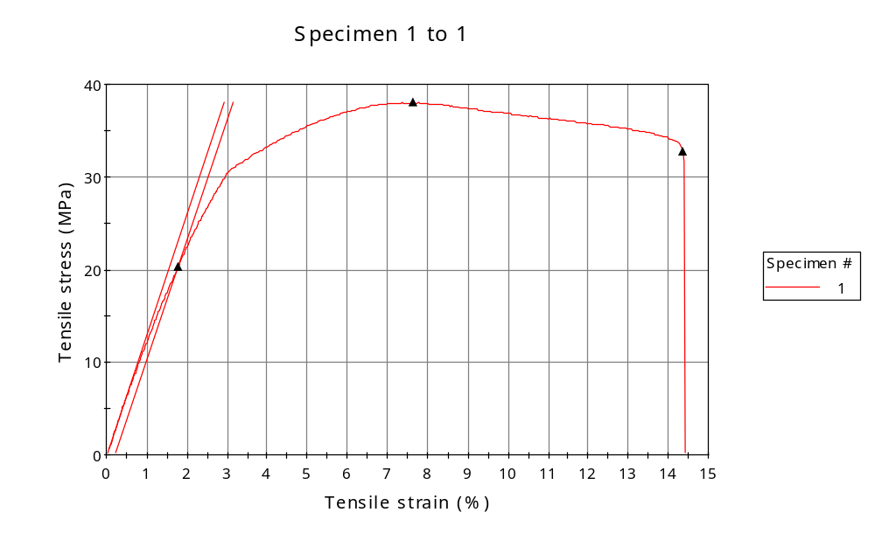
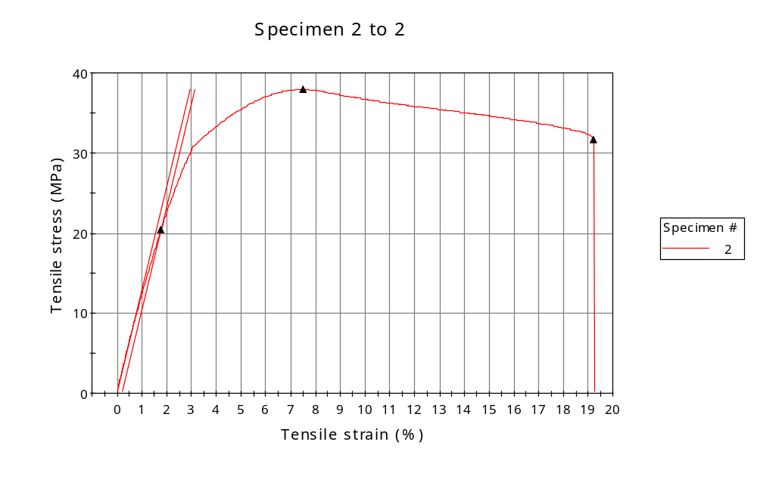
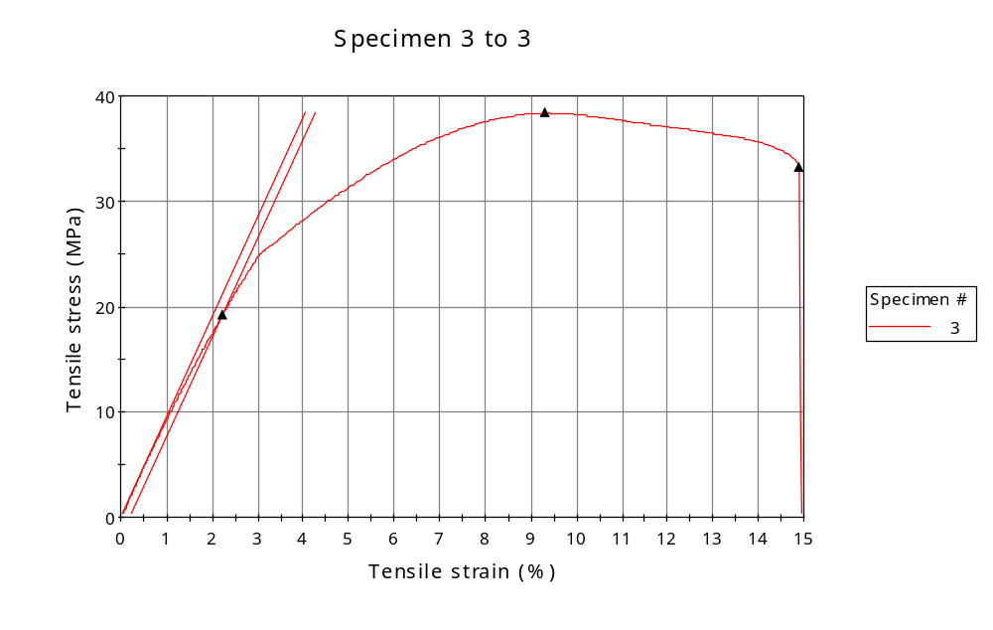
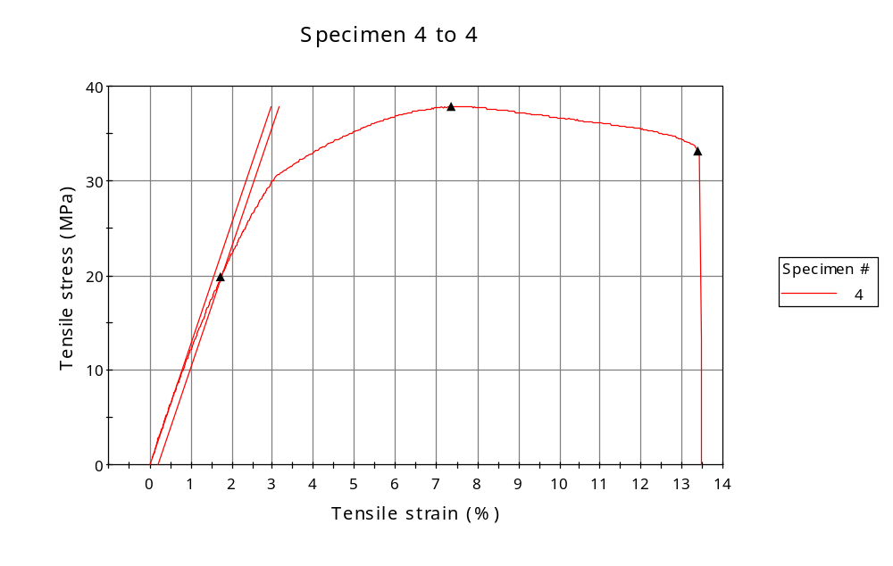
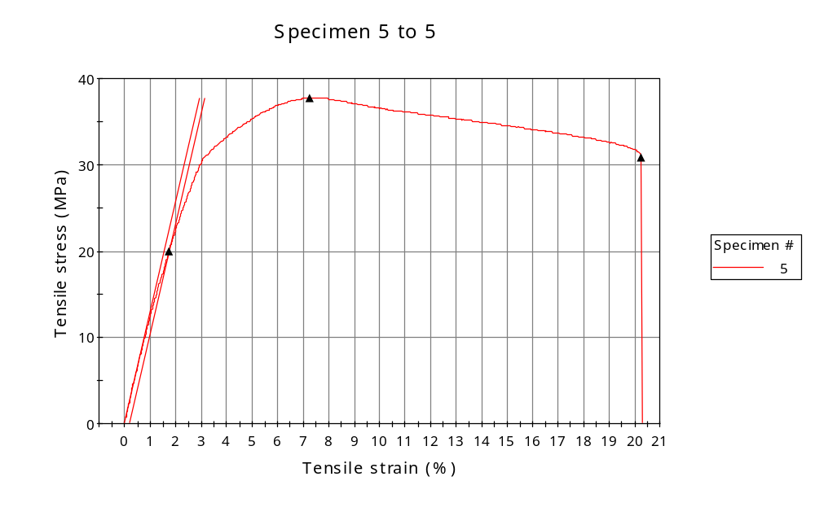
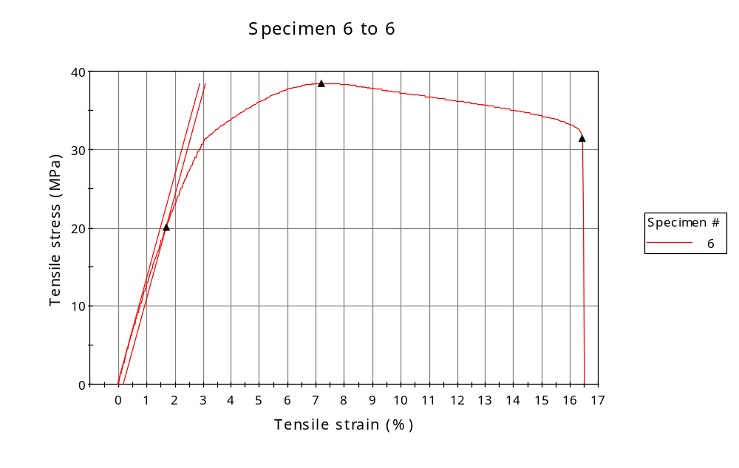
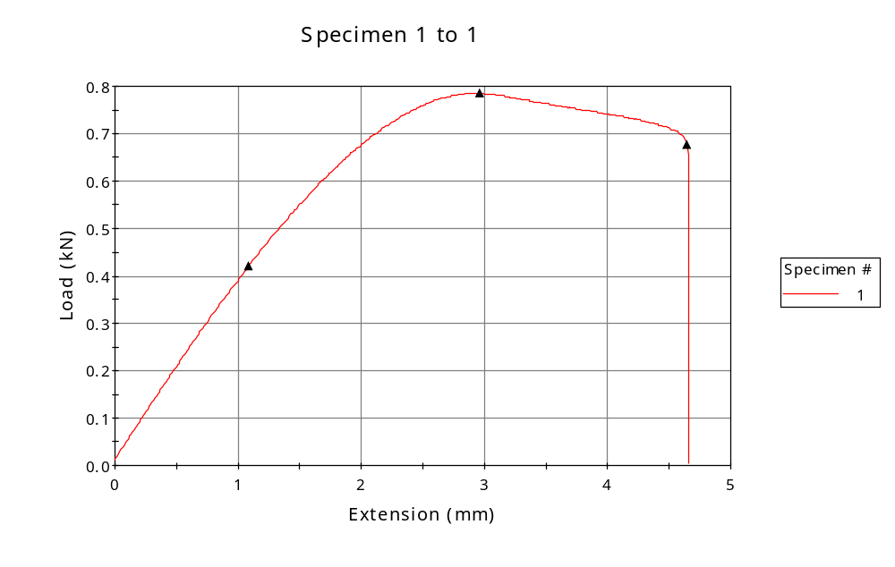
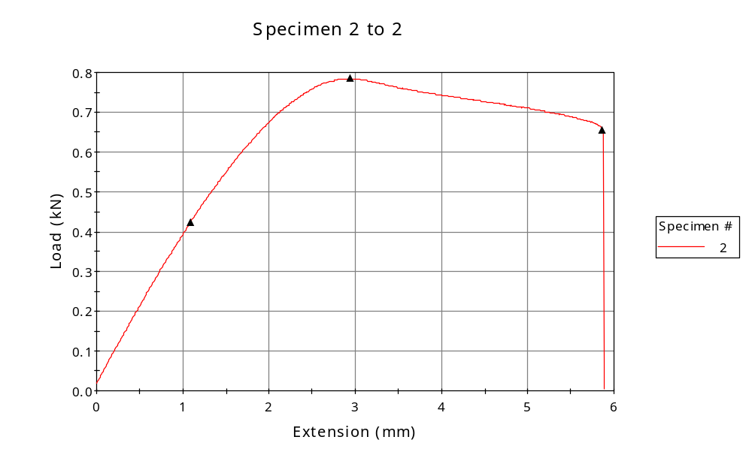
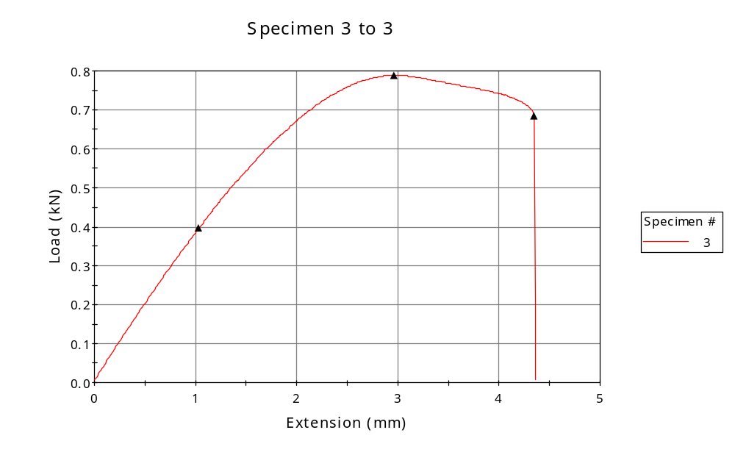
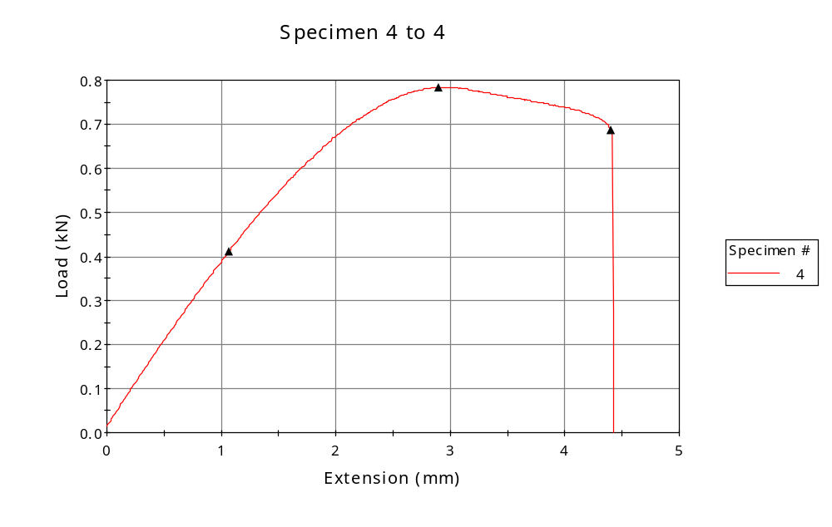
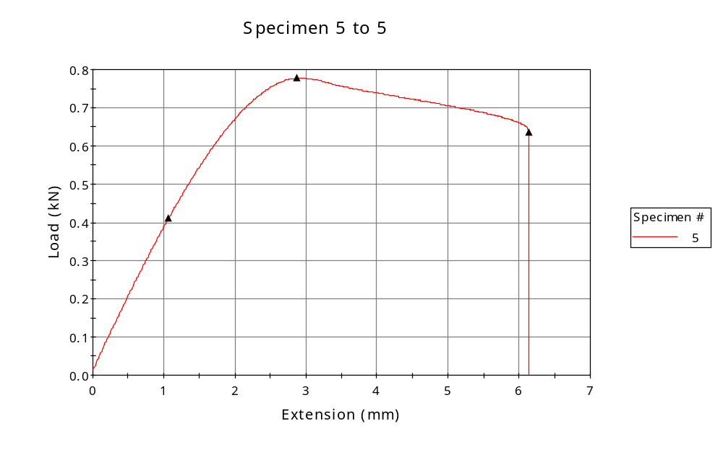
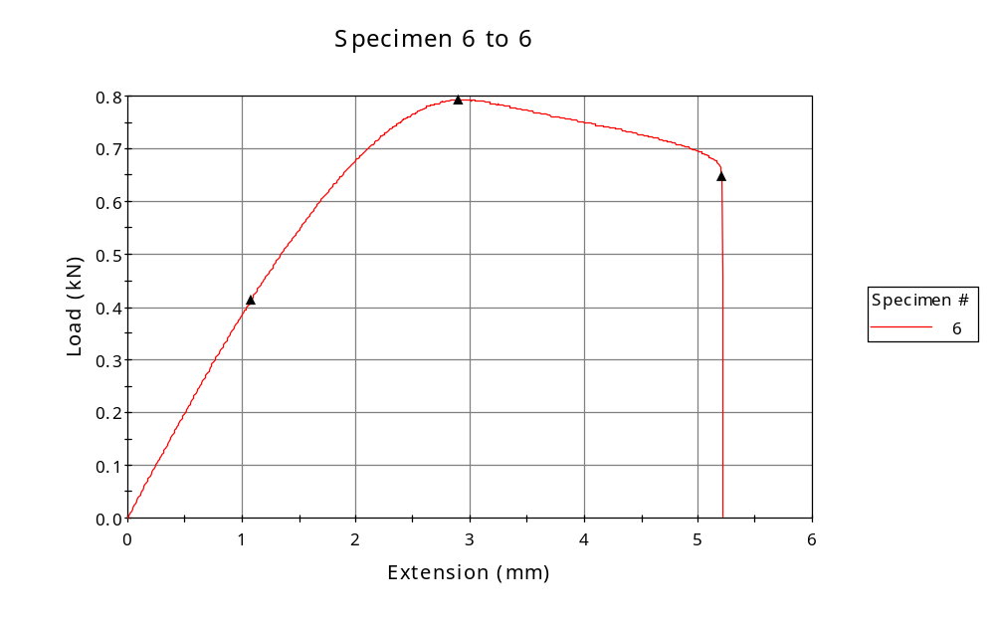

 | CP ID | Length  (mm) | Width  (mm) | Thickness  (mm) | Modulus (Automatic Young's)  (MPa)
1 | CP-FDM_45_01 | 25.00 | 6.02 | 3.43 | 1298
2 | CP-FDM_45_02 | 25.00 | 6.03 | 3.43 | 1280
3 | CP-FDM_45_03 | 25.00 | 6.02 | 3.42 | 947
4 | CP-FDM_45_04 | 25.00 | 6.07 | 3.42 | 1282
5 | CP-FDM_45_05 | 25.00 | 6.03 | 3.42 | 1287
6 | CP-FDM_45_06 | 25.00 | 6.03 | 3.42 | 1326
Maximum |  | 25.00 | 6.07 | 3.43 | 1326
Minimum |  | 25.00 | 6.02 | 3.42 | 947

 | Load at Fy ( 0.2 %) - LE  (kN) | Tensao em Fy ( 0.2 %) - LE  (MPa) | Deformacao em Fy ( 0.2 %) - LE  (%) | Forca Max  (kN) | Tensao na Forca Max - LR  (MPa)
1 | 0.420 | 20.35 | 1.778 | 0.785 | 38.02
2 | 0.423 | 20.47 | 1.779 | 0.784 | 37.93
3 | 0.396 | 19.26 | 2.235 | 0.789 | 38.37
4 | 0.411 | 19.85 | 1.744 | 0.784 | 37.82
5 | 0.412 | 19.99 | 1.729 | 0.778 | 37.76
6 | 0.414 | 20.08 | 1.697 | 0.793 | 38.47
Maximum | 0.423 | 20.47 | 2.235 | 0.793 | 38.47
Minimum | 0.396 | 19.26 | 1.697 | 0.778 | 37.76

 | Deformacao na Forca Max - LR  (%) | Forca na Forca na Quebra - LQ  (kN) | Deformacao na Forca na Quebra - LQ  (%)
1 | 7.634 | 0.676 | 14.367
2 | 7.502 | 0.656 | 19.202
3 | 9.325 | 0.684 | 14.892
4 | 7.359 | 0.686 | 13.392
5 | 7.249 | 0.636 | 20.283
6 | 7.206 | 0.648 | 16.440
Maximum | 9.325 | 0.686 | 20.283
Minimum | 7.206 | 0.636 | 13.392

